Lab_Assignment_2.1
NAME:B.AKARSH
H.NO:2303A53018
BATCH-46

Task 1: Statistical Summary for Survey Data
❖ Scenario:You are a data analyst intern working with survey responses stored asnumerical lists.
❖ Task:Use Google Gemini in Colab to generate a Python function that reads a list of numbers and calculates the mean, minimum, and maximum values.
INPUT:
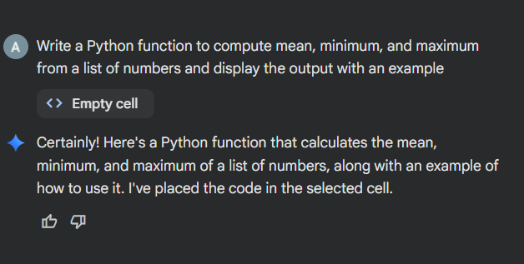
CODE:
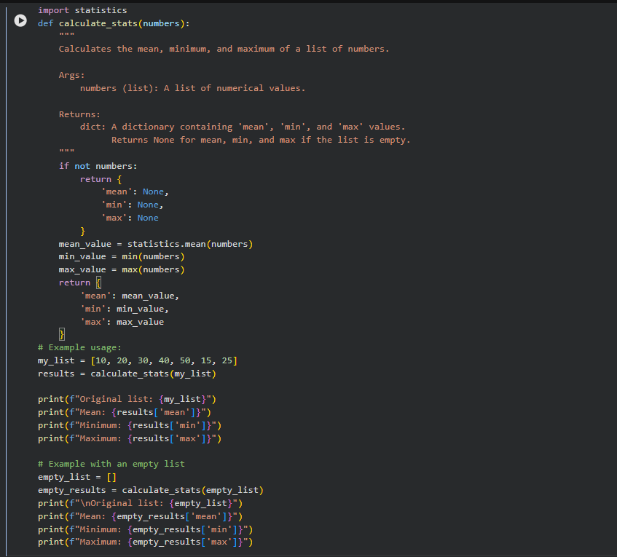
OUTPUT:
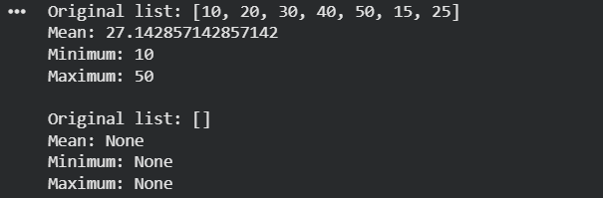
# Function to calculate statistical summary of survey data
# Calculate the mean value of the list
# Find the minimum value in the list
# Find the maximum value in the list
# Return mean, minimum, and maximum values
# Sample list of survey responses
# Call the function
# Display the results

Task 2: Armstrong Number – AI Comparison
Scenario: You are evaluating AI tools for numeric validation logic.
Task:Generate an Armstrong number checker using Gemini and GitHub Copilot.
Compare their outputs, logic style, and clarity.
❖ Expected Output:
➢ Side-by-side comparison table
➢ Screenshots of prompts and generated code
INPUT PROMPT:
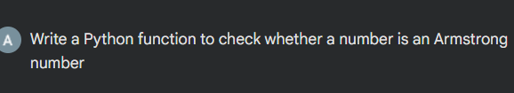
CODE:
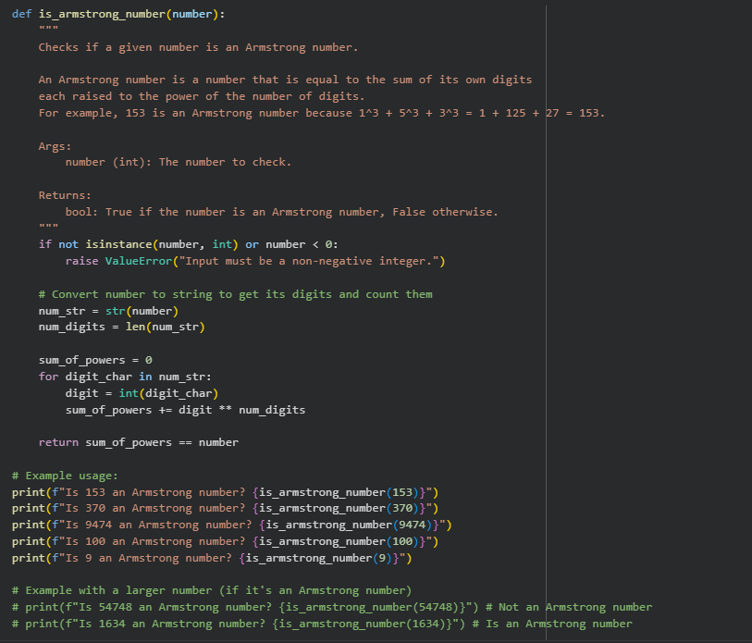
OUTPUT:
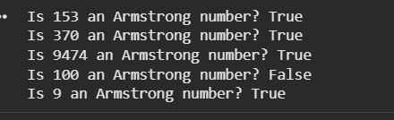
# Function to check whether a number is an Armstrong number
# Convert the number into individual digits
# Count the number of digits
# Calculate the sum of each digit raised to the power of total digits
# Compare the calculated sum with the original number
# Display whether the number is Armstrong or not
# Take input from the user
# Call the function and show the result

Task 3: Leap Year Validation Using Cursor AI
Scenario:You are validating a calendar module for a backend system.
❖ Task:Use Cursor AI to generate a Python program that checks whether a given year is a leap year.
Use at least two different prompts and observe changes in code.
❖ Expected Output:
➢ Two versions of code
➢ Sample inputs/outputs
➢ Brief comparison
INPUT:
OUTPUT:
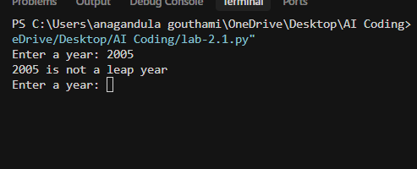
COMMENTS:
# Program to check whether a given year is a leap year
# Take year input from the user
# Check if the year is divisible by 400
# Check if the year is divisible by 100
# Check if the year is divisible by 4
# Display whether the year is a leap year or not
# Function to validate leap year logic
# Call the function and print the result

Task 4: Student Logic + AI Refactoring (Odd/Even Sum)
❖ Scenario:Company policy requires developers to write logic before using AI.
❖ Task:Write a Python program that calculates the sum of odd and even numbers
in a tuple, then refactor it using any AI tool.
❖ Expected Output:
➢ Original code
➢ Refactored code
➢ Explanation of improvements
INPUT:
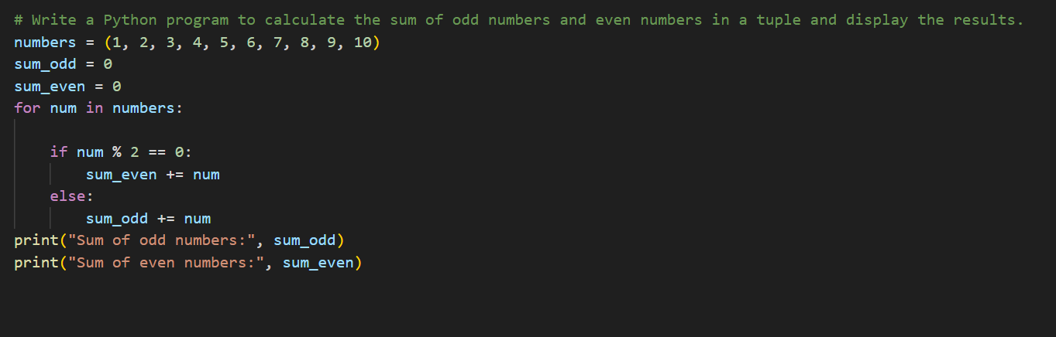
OUTPUT:
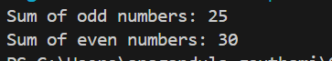
COMMENTS:
# Calculate sum of even and odd numbers
# Loop through the tuple
# Check even or odd
# Add values accordingly
# Print the results
# Refactored using sum()
# Code is shorter and clearer

